Chapter 08: Coloring, Covering and Partitioning

Table of Contents

Chromatic Partitioning 5

Independent Sets 5

Finding Maximal Independent Sets 6

Dominating Set 9

Finding Minimal Dominating Sets 10

Matchings 11

Coverings 15

The purpose of **graph coloring** is to specify colours for each vertex in a graph such that no two adjacent vertices have the same colour. Of course, we can do this by specifying a different colour for each vertex, thus requiring $n$ colours, but the challenge is to find the minimum number of colours with which this can be achieved.

A graph that requires $k$ different colours for proper colouring and no less is called a $k$**-chromatic graph**. Here, $k$ is the **chromatic number**. For example, for the graph below, the chromatic number if $3$.

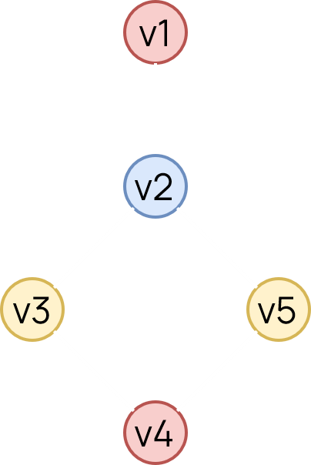

When considering graph colouring, we only need to think about **simple, connected graphs**. Disconnected graphs are meaningless to us since the colouring of one component will not affect any of the others. Parallel edges and self-loops also do not affect the colouring process.

We will next be looking into a few specific types of graphs and how they can be coloured.

* **Isolated Graphs** – Since the graph is isolated, we can use a single colour for all of the vertices. Thus, these graphs are **1-chromatic**.
* A graph with a **single edge** must be at least **2-chromatic**.
* A **complete graph** with $n$ vertices is $n$**-chromatic**, since each vertex is adjacent to all of the others. In fact, if any graph even has a **subgraph** that is a complete graph with $r$ vertices, the entire graph must be at least $r$**-chromatic**.
* If a graph consists of a **single circuit** of an **even length**, it is $2$**-chromatic**. If it is of **odd length**, it is $3$**-chromatic**. This can be seen in the diagrams below:



Theorem 8.1: Every tree with 2 or more vertices is $2$-chromatic.

Proof:

Every vertex that is an even distance away from the root, $v$, will have the same colour as $v$. Every vertex that is an odd distance away from $v$ will have a different colour. Since there is a single path between any two vertices in the tree, there can be no adjacent vertices with the same colour (since we just coloured the only adjacent vertices possible with different colours).



Theorem 8.2: A graph where $\left|e\right|≥1$ will be $2$-chromatic if and only if it has no circuits of odd length.

Proof:

Suppose we have a graph $G$ which only has circuits of even length. The spanning tree of this graph is 2-chromatic. We can add chords to the spanning tree one by one to recreate $G$. Since there are no circuits of odd length, the end vertices of any chord we add will already have different colours.

Conversely, if $G$ has any circuit of odd length, we will need at least 3 colours just for that circuit.

Theorem 8.3: The chromatic number of a complete graph is $1+d_{max}$ at most, where $d_{max}$ is the maximum degree of the vertices of the graph. If the graph is not complete, the chromatic number is $d_{max}$ at most.

Any **2-chromatic** graph is **bipartite**. We can see this easily because we can separate the vertices that are of different colours into sets. The process of colouring ensures that the vertices in the same set are not adjacent to each other. In a similar manner, all bipartite graphs are also 2-chromatic with one exception: a graph of 2 isolated vertices, which is a bipartite graph but is 1-chromatic.

We can extend this concept to $p$**-partite** graphs, where the vertices can be divided into $p$ sets with the vertices in the same set not being adjacent. For such graphs, $k≤p$. A **complete $p$-partite** graph would be $p$-chromatic.

## Chromatic Partitioning

### Independent Sets

Based on the colours we assign to the vertices of a graph, we can partition them into **independent sets**. For example in the graph below, possible independent sets are $\left\{v_{1},v_{4}\right\}$, $\left\{v_{2}\right\}$ and $\left\{v_{3},v_{5}\right\}$. These are independent sets because no two vertices in any one of the sets are adjacent.



If we have an independent set to which we cannot add any more vertices without breaking its independence, it is called a **maximal independent set**. In the graph below, $\left\{a,c,d,f\right\}$, $\left\{b,g\right\}$ and $\left\{b,f\right\}$ are all maximal independent sets, but $\left\{a,c,d\right\}$ is not.



The number of vertices in the largest independent set is called the **independence number**, $β\left(G\right)$. For the graph above, this is $4$, for the set $\left\{a,c,d,f\right\}$.

### Finding Maximal Independent Sets

To find a maximal independent set, we can simply start at any vertex and keep adding vertices that are not adjacent to any of the vertices we have already added. This set, however, is not guaranteed to be the largest one. One (inefficient) method to find all the maximal independent sets (from which we can then select the largest) is to use **Boolean arithmetic**.

In Boolean arithmetic, we will consider $a+b$ to mean that either vertex $a$ or vertex $b$ or both are being included in the set, $ab$ to mean that both are being included and $a^{'}$ to mean $a$ is being excluded.

For any graph, the two vertices on either end of an edge can be expressed as $xy$. The sum of these products is given by $φ=∑xy ∀xy in G$. The complement of this can be expressed as $φ^{'}=f_{1}+f_{2}+…+f_{k}$.



A given set is maximally independent if and only if $φ=0$ (logical false), since none of the vertices in that set are on either end of an edge. Thus, $φ^{'}=1$ (logical true), which can only be true if at least one of $f_{i}=1$.

For the entire graph, $φ=ab+bc+bd+be+ce+de+ef+eg+fg$. From here,

$$φ^{'}=\left(a^{'}+b^{'}\right)\left(b^{'}+c^{'}\right)\left(b^{'}+d^{'}\right)\left(b^{'}+e^{'}\right)\left(c^{'}+e^{'}\right)\left(d^{'}+e^{'}\right)\left(e^{'}+f^{'}\right)\left(e^{'}+g^{'}\right)\left(f^{'}+g^{'}\right)$$

We can multiply all of this using the usual properties of Boolean arithmetic such as:

$aa=a$

$a+a=a$

$a+ab=a$

From here, we get $φ^{'}=b^{'}e^{'}f^{'}+b^{'}e^{'}g^{'}+a^{'}c^{'}d^{'}e^{'}f^{'}+a^{'}c^{'}d^{'}e^{'}g^{'}+b^{'}c^{'}d^{'}f^{'}g^{'}$. Each of these terms represent the vertices we must **exclude** to get one maximal independent set. Thus, the maximal independent sets are $acdf$, $acdg$, $bg$, $bf$ and $ae$. Thus, $β\left(G\right)=4$.

The minimum number of maximal independent sets required to cover all the vertices will give us the **chromatic number** of the graph. For this graph, we can use the maximal independent sets $acdf$, $bg$ and $ae$. Thus, the chromatic number is $3$. We will assign one colour to each of these sets.

**Chromatic partitioning** is the process of finding the smallest number of disjoint, independent sets which cover all the vertices. By going over all possible maximal independent sets and selecting the smallest number of sets that include all the vertices, we can solve this problem. This method is, of course, extremely inefficient.

For the graph above, valid chromatic partitions include:

$\left\{\left(a,c,d,f\right),\left(b,g\right)\left(e\right)\right\}$

$\left\{\left(a,c,d,g\right),\left(b,f\right),\left(e\right)\right\}$

$\left\{\left(c,d,f\right),\left(b,g\right),\left(a,e\right)\right\}$

$\left\{\left(c,d,g\right),\left(b,f\right),\left(a,e\right)\right\}$

If a graph has only one chromatic partitioning, it is said to be **uniquely colourable**. The graph above is not uniquely colourable, but the one below is.



### Dominating Set



A **dominating set** is a set of vertices such that every vertex in the graph is either included in the set, or is adjacent to a vertex that is included in the set. For the graph above, $\left\{a,b,c,d,f\right\}$ forms a dominating set.

A **minimal dominating set** is a dominating set such that no vertex can be removed without destroying its dominance property. For the graph above, $\left\{a,c,d,f\right\}$ is one possible minimal dominating set. The number of vertices in the **smallest minimal dominating set** is known as the **domination number**, $α\left(G\right)$.

From the above definitions, we can make several observations:

* Any vertex in a complete graph constitutes a minimal dominating set.
* Every dominating set contains at least one minimal dominating set.
* A graph can have multiple minimal dominating sets of different sizes.
* A minimal dominating set may or may not be independent.
* Every maximal independent set is a dominating set. If this were not the case, there would have to be some vertex that is not in the set and is also not adjacent to any of the vertices in the set. Such a vertex could be added to the set without destroying its independence property, meaning the set is not currently maximally independent.
* An independent set has the dominance property if and only if it is maximally independent. Thus, an independent dominating set is just a maximal independent set.
* In any graph $G$, $α\left(G\right)≤β\left(G\right)$.

### Finding Minimal Dominating Sets

For every vertex $v_{i}$ in $G$, let us form a Boolean product of sums $(v_{i}+v_{i1}+v_{i2}+…+v_{id}$), where $v_{i1}$, $v_{i2}$, $…$, $v_{id}$ are the vertices adjacent to $v_{i}$ and $d$ is the degree of $v_{i}$. We only need one of these vertices (thus the OR operation). To form a minimal dominating set, this operation must be repeated for each of the vertices in the graph. Thus,

$$θ=\prod{\left(v_{i}+v_{i1}+v_{i2}+…+v_{id}\right) ∀v_{i} in G}$$



For the graph above,

$$θ=\left(a+b\right)\left(b+c+d+e+a\right)\left(c+b+e\right)\left(d+b+e\right)\left(e+b+c+d+f+g\right)\left(f+e+g\right)\left(g+e+f\right)$$

In Boolean arithmetic, $\left(x+y\right)x=x$, which allows us to reduce the above equation to:

$$θ=\left(a+b\right)\left(b+c+e\right)\left(b+d+e\right)\left(e+f+g\right)$$

$$=ae+be+bf+bg+acdf+acdg$$

Each of these terms represents a minimal dominating set. Since the smallest set has 2 vertices, $α\left(G\right)=2$.

## Matchings

Suppose we have four applications available for six open positions, and each application is qualified for a different subset of these positions. We can represent this information using a bipartite graph, with the edges between applications and positions representing that the application is qualified for the position.

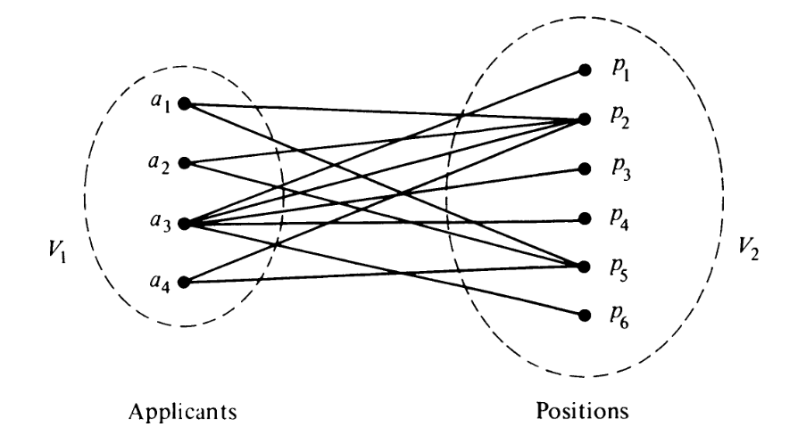

We want to assign each of the applicants to a position for which they are qualified. This problem is called **matching** of one set of vertices to another. More formally, a matching in a graph is a subset of edges in which no two edges are adjacent. For the graph above, this is not possible.

A **maximal matching** is a matching in a graph such that no edge can be added to the set. For the graphs below, the bold lines form maximal matchings.

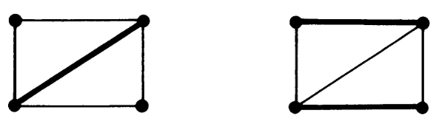

The number of edges in the largest maximal matching of a graph is called its **matching number**.

Matching is generally studied in reference to bipartite graphs. In a bipartite graph with partitions $V_{1}$ and $V_{2}$, if there is a matching such that every vertex in $V_{1}$ is matched against some vertex in $V_{2}$, the matching is called a **complete matching** or a **perfect matching**. A perfect matching is guaranteed to be the largest maximal matching, but the largest maximal matching may not be a perfect matching (in cases where a perfect matching does not exist).

A necessary condition to form a perfect matching is that the number of vertices in $V_{2}$ (the number of vacant positions) be at least as large as the number of vertices in $V_{1}$ (the number of applicants). This is a necessary condition but is not a sufficient one.

Theorem 8.7: A complete matching of $V_{1}$ into $V_{2}$ in a bipartite graph exists if and only if every subset of $r$ vertices in $V_{1}$ is collectively adjacent to $r$ or more vertices in $V_{2}$ for all values of $r$. [Hall’s Theorem]

To show that this theorem is correct, consider another problem. Suppose five senators are members of three committees as shown below. We want to select one distinct representative from each of the committees.

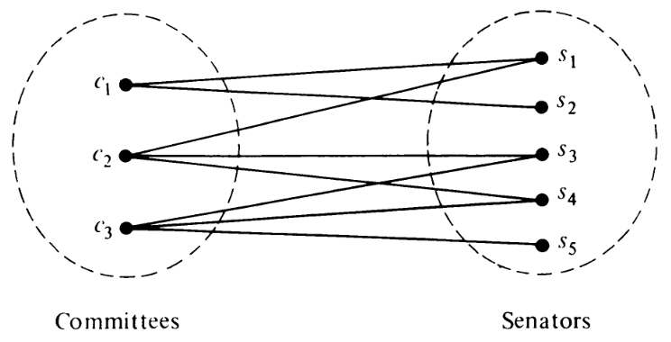

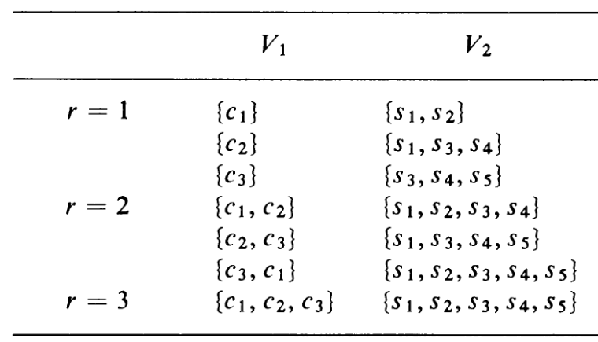

For each case, we see that $\left|V_{1}\right|≤\left|V_{2}\right|$, which means we are guaranteed to find a perfect matching.

In most cases however, we can use a simplified version of the previous theorem.

Theorem 8.8: In a bipartite graph, a complete matching of $V_{1}$ into $V_{2}$ exists if (but not only if) there is a positive integer $m$ for which the following condition is satisfied:

degree of every vertex in $V_{1}≥m≥$ degree of every vertex in $V_{2}$

For the applicant-posting problem we saw earlier,

Degrees in $V_{1}$: 2, 2, 5, 2

Degrees in $V_{2}$: 1, 4, 1, 1, 3, 1

As such, this theorem tells us that no perfect matching can be found.

If we fail to find a perfect matching, we will most likely be interested in the maximal matching, pairing off as many vertices from $V_{1}$ with those in $V_{2}$ as possible. Suppose a set of $r$ vertices from $V_{1}$ is collectively incident on a set of $q$ vertices from $V_{2}$. The maximum value of the number $r-q$ taken over all values of $r$ and all subsets of $V_{1}$ is called the **deficiency**, $δ\left(G\right)$.

For the senator-committee problem, the table below shows us that $δ\left(G\right)=-1$.

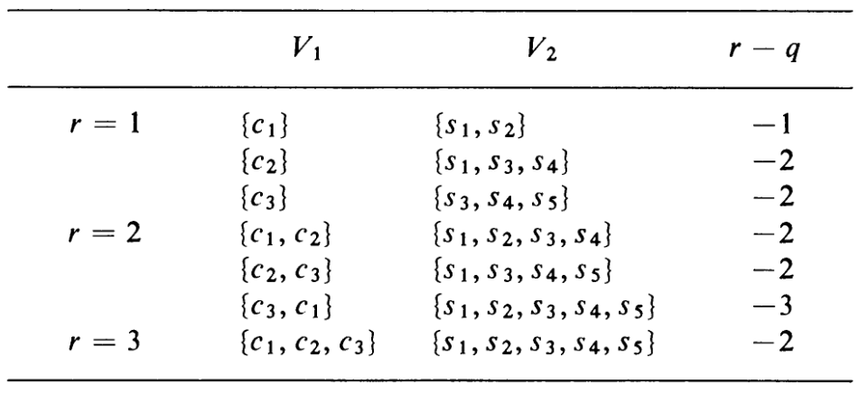

In terms of deficiency, we can re-write theorem 8.7 to state that a complete matching exists in a bipartite graph if and only if $δ\left(G\right)≤0$.

Theorem 8.9: The maximal number of vertices is set $V_{1}$ that can be matched into $V_{2}$ is equal to the number of vertices in $V_{1}-δ\left(G\right)$.

The value $n\left(V_{1}\right)-δ\left(G\right)$ will thus give us the number of applicants we can hire for the applicant-posting problem.

## Coverings

A set of edges in a graph is said to **cover** the graph if every vertex in the graph is incident on at least one edge in the set. The set is called an **edge covering**. For example, the set of edges of a connected graph itself forms a covering, as does a spanning tree or a Hamiltonian circuit.

If the set is such that no edge can be removed without destroying the ability to cover the graph, the set is called a **minimal covering**. The graphs below show two possible minimal coverings.

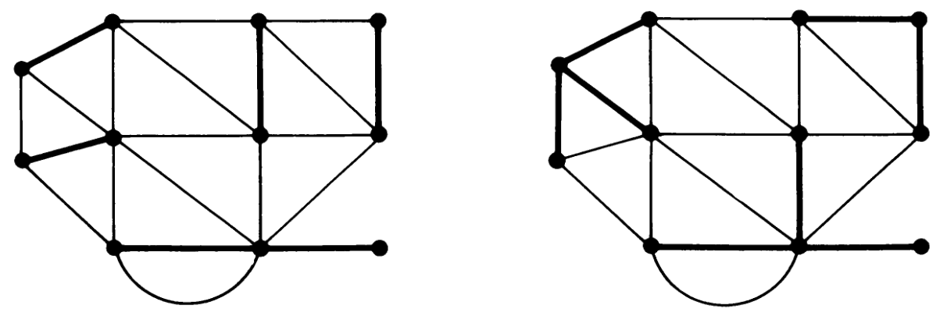

There are several observations that can be made here:

* A covering exists if and only if the graph has no isolated vertices.
* A covering of an $n$-vertex graph will have at least $\left\lceil \frac{n}{2}\right\rceil$ edges.
* Every pendent edge in a graph must be included in every covering of the graph.
* Every covering contains a minimal covering.
* The set of edges $g$ is a covering if and only if the degree for each vertex in $\left(G-g\right)≤($ the degree of the same vertex in $G)-1$.
* No minimal covering can contain a circuit. Thus, the minimal covering for an $n$-vertex graph can have at most $n-1$ edges.
* A graph can have several minimal coverings. The number of edges in the smallest minimal covering is called the **covering number**.